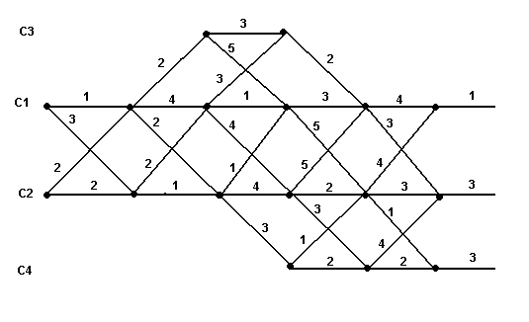
Etapa 1

P: 4 + 1 = 5
VC1 (1)
C: 3+3 = 6

P: 3+3 = 6
VC2 (1)
CC1: 1 + 4 = 5
C:
CC4: 3 + 1 = 4

P: 2 + 3 = 5

VC4 (1)
C: 4 +3 = 7

Etapa 2:

VC3 (2) → C: 5 +2 = 7

P→ 5 + 3 = 8
VC1 (2)
C → 4 + 5 = 9

P → 4 + 2 = 6
VC2 (2)
CC1→ 5 + 5 = 10
C
CC4 → 5 + 3 = 8

P → 5 +2 = 7

VC4 (2)
C → 4 + 1 = 5

Etapa 3:

P → 7 + 3 = 10
VC3 (3)
C → 8 + 5 = 13

P → 8 + 1 = 9
VC1 (3)
CC4 → 5 + 3 = 8
C:
CC2 → 6 + 4 = 10

P → 6 + 4 = 10
VC2 (3)
CC1 → 8 + 1 = 9
C
CC4 → 5 + 3 = 8

Etapa 4:

P → 8 + 4 = 12
VC1 (4)
CC3 → 10 + 2 = 12
C
CC2 → 8 + 2 = 10

P → 8 + 1 = 9
VC2 (4)

C → 8 + 2 = 10

Etapa 5:

P → 10 + 1 = 11
VC1 (5)

C → 9 + 3 = 12

P → 9 + 2 = 11

VC2 (5)
C → 10 + 2 = 12

Mínimos recorridos: 2

